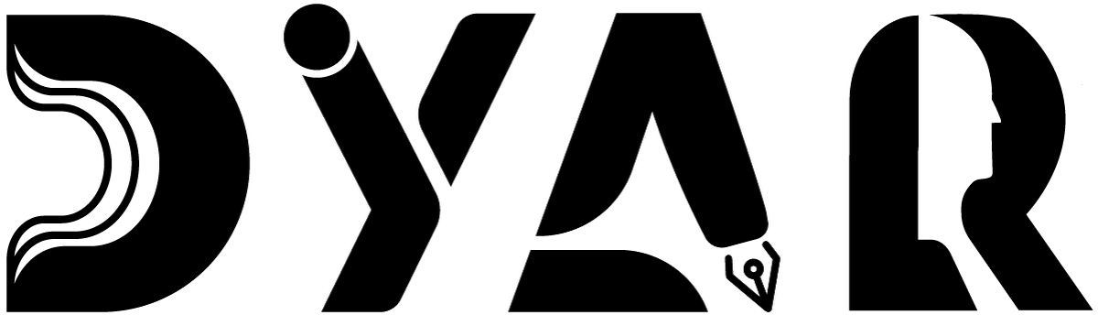
An NDIS Service Provider
RESOURCES HUB · EMERGENCY CONTACTS
Emergency Contact Details
Important numbers to keep handy — 000, DYAR, health, mental health crisis, safety, utilities.
Aligned to NDIS Practice Standards · NDIS Code of Conduct · NDIS Act 2013

Version 2 · 12 May 2026
DYAR Pty Ltd
NDIS Provider No. pending (Application 4-LRFP0J8) · ABN 68 695 255 504
Unit 1, 136 Main Street, Osborne Park WA 6017 · PO Box 8052, East Subiaco WA 6008
0470 540 306 · hello@dyar.com.au · Whadjuk Country

Emergency Contact Details
Important numbers — keep these somewhere you can find them fast
Life-threatening emergency
000
Police · Ambulance · Fire
Use 000 if anyone is hurt, in danger, or there is a fire.
DYAR contacts
Mehdi Dabire — Director / Service Manager
Phone: 0470 540 306 (day + night for urgent)
Email: hello@dyar.com.au
Office: Unit 1, 136 Main Street, Osborne Park WA 6017
Health
Police (non-emergency): 131 444
HealthDirect: 1800 022 222
Poisons Information: 13 11 26
Your GP: _______________________ (write your GP's name + number)
Your pharmacy: _______________________
Mental health crisis
Mental Health Emergency Response Line: 1300 555 788
Lifeline (sad or scared): 13 11 14
Kids Helpline (under 25): 1800 55 1800
Suicide Call Back Service: 1300 659 467
Beyond Blue: 1300 22 4636
Safety + advocacy
NDIS Quality and Safeguards Commission: 1800 035 544
1800RESPECT (domestic violence): 1800 737 732
Crime Stoppers: 1800 333 000
Energy + utilities (WA)
Synergy (electricity): 13 13 53
Water Corp: 13 13 75
Gas leak (ATCO): 13 13 52
Other
Your support coordinator: _______________________
Your behaviour support practitioner: _______________________
Your nominee / family / advocate: _______________________
Your favourite trusted person: _______________________
Print this page. Put it on your fridge. Save the numbers in your phone.
___________________________________________
DYAR Pty Ltd · ABN 68 695 255 504 · Unit 1, 136 Main Street, Osborne Park WA 6017 · 0470 540 306 · hello@dyar.com.au · dyar.com.au · Whadjuk Country · V1 19 May 2026

